

Symbiosis Institute of Technology, Pune
Faculty of Engineering CSE- Academic Year 2025-26
Compiler Construction Lab Batch 2022-26

Lab Assignment No: - 10
Name of Student | Yash Bhisekar
PRN No. | 22070122254
Batch | 2022-26
Class | CSC-3
Academic Year & Semester | 2025-26  VII
Date of Performance | 25/09/2025
Title of Assignment | Intermediate code (IC) generator for arithmetic expression.
Practice Questions | 1. YACC program for IC generation for the expression involving parenthesis.
Source Code | LEX CODE:  %{  #include "y.tab.h" #include <string.h> #define strdup _strdup  %}  %%  [0-9]+ { yylval.str = strdup(yytext); return NUM; }  [a-zA-Z][a-zA-Z0-9]* { yylval.str = strdup(yytext); return ID; } [ \t\n] ;  . { return yytext[0]; }  %%  int yywrap() { return 1; }  YACC CODE:

%{
#include <stdio.h> #include <stdlib.h> #include <string.h>

int temp_count = 0; char temp[10];

char* newtemp() {
sprintf(temp, "t%d", temp_count++); return strdup(temp);
}

extern int yylex(void);
void yyerror(const char *s);
%}

%union { char *str;
}

%token <str> ID NUM
%left '+' '-'
%left '*' '/'
%type <str> E

%%

S : E { printf("Result: %s\n", $1); }
;

E : E '+' E {
char *t = newtemp();
printf("%s = %s + %s\n", t, $1, $3);

$$ = t;
}
| E '-' E {
char *t = newtemp();
printf("%s = %s - %s\n", t, $1, $3);
$$ = t;
}
| E '*' E {
char *t = newtemp();
printf("%s = %s * %s\n", t, $1, $3);
$$ = t;
}
| E '/' E {
char *t = newtemp();
printf("%s = %s / %s\n", t, $1, $3);
$$ = t;
}
| '(' E ')' { $$ = $2; }
| ID { $$ = strdup($1); }
| NUM { $$ = strdup($1); }
;

%%

void yyerror(const char *s) { printf("Error: %s\n", s);
}

int main(void) { return yyparse();
}

INPUT:

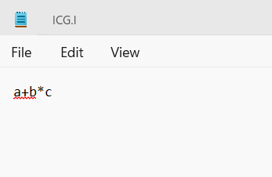

Practice Question LEX CODE:
%{
#include "y.tab.h" #include <string.h>
#define strdup _strdup /* Windows fix */
%}

%%

[0-9]+ { yylval.str = strdup(yytext); return NUM; }
[a-zA-Z][a-zA-Z0-9]* { yylval.str = strdup(yytext); return ID; } "(" { return '('; }
")" { return ')'; }
[+\-*/] { return yytext[0]; }
[ \t\n] ; /* ignore spaces */
. { return yytext[0]; }

%%

int yywrap() { return 1; }
YACC CODE:
%{
#include <stdio.h> #include <stdlib.h>

#include <string.h>

// Forward declarations int yylex();
int yyerror(const char *s);

int tempCount = 0;

char* newtemp() {
char* buf = (char*)malloc(8); sprintf(buf, "t%d", tempCount++); return buf;
}
%}

%union { char* str; }

%token <str> ID NUM
%left '+' '-'
%left '*' '/'
%right UMINUS
%type <str> expr

%%

S : expr { printf("Result: %s\n", $1); }
;

expr
: expr '+' expr {
char* t = newtemp();
printf("%s = %s + %s\n", t, $1, $3);

$$ = t;
}
| expr '-' expr {
char* t = newtemp();
printf("%s = %s - %s\n", t, $1, $3);
$$ = t;
}
| expr '*' expr {
char* t = newtemp();
printf("%s = %s * %s\n", t, $1, $3);
$$ = t;
}
| expr '/' expr {
char* t = newtemp();
printf("%s = %s / %s\n", t, $1, $3);
$$ = t;
}
| '-' expr %prec UMINUS { char* t = newtemp(); printf("%s = -%s\n", t, $2);
$$ = t;
}
| '(' expr ')' { $$ = $2; }
| ID
| NUM
;

%%

int main() {
printf("Enter expression: "); yyparse();

return 0;
}

int yyerror(const char *s) { printf("Syntax error: %s\n", s); return 0;
}
INPUT:

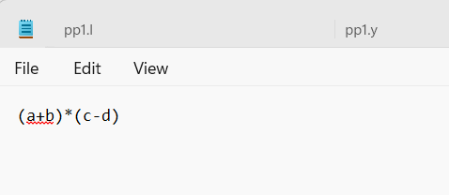

Output Screenshot | Intermediate Code Generation:  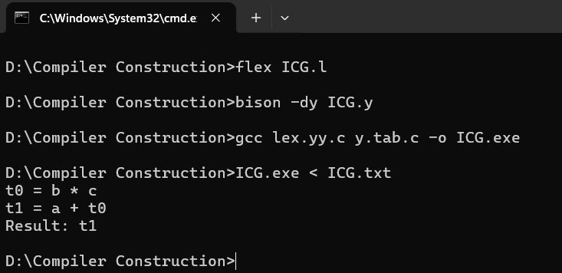  Practice Question

 | 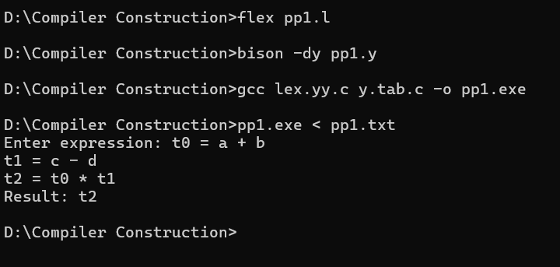
Post lab questions | 1. YACC program for IC generation for the expression involving programming constructs
 | Lex Code:
%{
#include "y.tab.h" #include <string.h> #define strdup _strdup
%}
 | %%
"if" { return IF; } "else" { return ELSE; }
"while" { return WHILE; } "(" { return '('; }
")" { return ')'; }
"{" { return '{'; }
"}" { return '}'; }
";" { return ';'; }
[0-9]+ { yylval.str = strdup(yytext); return NUM; }
[a-zA-Z][a-zA-Z0-9]* { yylval.str = strdup(yytext); return ID; } [+\-*/<>=!] { return yytext[0]; }
[ \t\n] ;
. { return yytext[0]; }
 | %%
 | int yywrap() { return 1; }
 | Yacc Code:
 | %{
 | #include <stdio.h>
 | #include <stdlib.h>
 | #include <string.h>

// Forward declarations int yylex();
int yyerror(const char *s);

int labelCount = 0, tempCount = 0;

char* newlabel() {
char* buf = (char*)malloc(8); sprintf(buf, "L%d", labelCount++); return buf;
}

char* newtemp() {
char* buf = (char*)malloc(8); sprintf(buf, "t%d", tempCount++); return buf;
}
%}

%union { char* str; }

%token <str> ID NUM
%token IF ELSE WHILE
%left '+' '-'
%left '*' '/'
%right UMINUS

%type <str> expr cond

%%

program : stmt { printf("Program parsed.\n"); }
;

stmt : IF '(' cond ')' stmt { char* l1 = newlabel(); char* l2 = newlabel();
printf("if %s goto %s\n", $3, l1); printf("goto %s\n", l2); printf("%s:\n", l1); printf("...then part...\n"); printf("%s:\n", l2);
}
| WHILE '(' cond ')' stmt { char* l1 = newlabel(); char* l2 = newlabel(); printf("%s:\n", l1);
printf("if %s goto %s\n", $3, l2); printf("goto END\n"); printf("%s:\n", l2); printf("...loop body...\n"); printf("goto %s\n", l1); printf("END:\n");
}
| '{' stmt '}'
| expr ';'
;

expr : expr '+' expr {
char* t = newtemp();
printf("%s = %s + %s\n", t, $1, $3);
$$ = t;
}
| expr '*' expr {
char* t = newtemp();
printf("%s = %s * %s\n", t, $1, $3);
$$ = t;

}
| ID
| NUM
;

cond : expr '<' expr {
char* t = newtemp();
printf("%s = %s < %s\n", t, $1, $3);
$$ = t;
}
;

%%

int main() {
printf("Enter construct: "); yyparse();
return 0;
}

int yyerror(const char *s) { printf("Syntax error: %s\n", s); return 0;
}
Input:

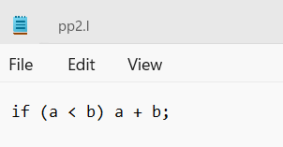
Output:

 | 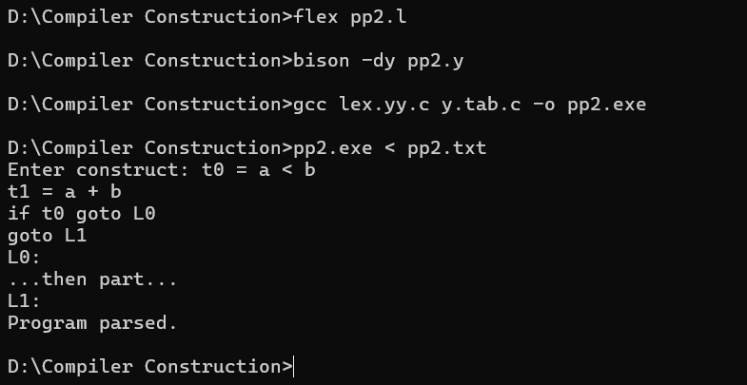
Conclusion | Thus, we have completed the Intermediate code (IC) generator for arithmetic expression.

